4D Latte Art (dancing latte art)  4D拉花 （在水面上起舞的拉花） |  |  | 
 |  |  | 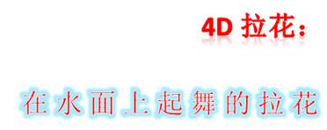
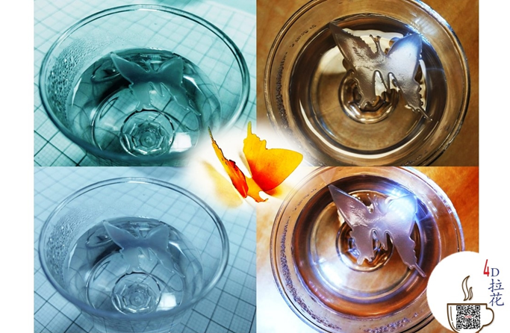


Food membrane unfolds atop hot or cold water (coffee or beverage) to show what was pre-printed on.  All food grade (membrane and ink). |  |  | 食品膜在冷水或热水（咖啡或其它饮料）上展开，显现预先印刷的图案。  所有材料（膜和打印墨）均为食品级。
Youtube video |  |  | 优酷视频
https://youtu.be/wlz5QHPooy8 |  |  | https://v.youku.com/v_show/id_XNDI5MzQ3ODM2OA==.html?spm=a2hzp.8244740.0.0

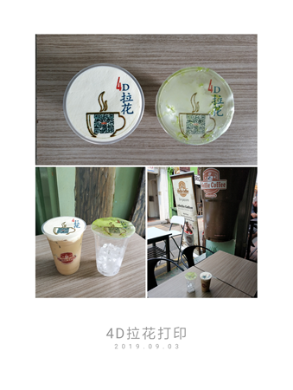 |  |  | 咖啡拉花机打印：标准打印和4D拉花膜打印效果  Comparison of normal selfie coffee and 4D latte art membrane using commercial coffee printer
 |  |  | Youtube video
 |  |  | https://www.youtube.com/watch?v=r-EuVAO_wik
 |  |  | 优酷视频
 |  |  | https://v.youku.com/v_show/id_XNDM0MjUyNzgzNg==.html?spm=a2hzp.8244740.0.0
 |  |  | 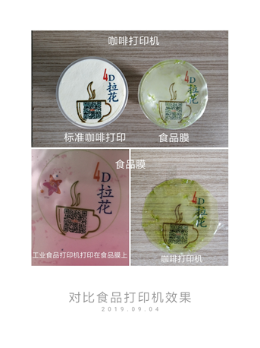
对比咖啡打印机和食品打印机效果
Comparison using selfie coffee printer and industrial food printer
食品打印机打印视频
Video of printing using industrial food printer

Youtube video
https://youtu.be/qyAfbX1N2_Q

优酷视频
https://v.youku.com/v_show/id_XNDM0NDU4OTkzNg==.html?spm=a2hzp.8244740.0.0

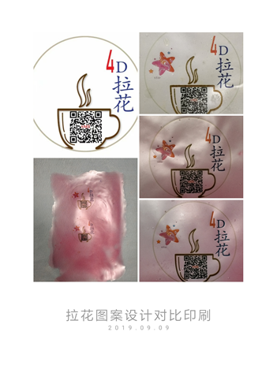
细看工业级食品打印的效果（二维码可读）
Closer-look of printing on food membrane (industrial food printer)

 |  |  | Youtube video
 |  |  | https://www.youtube.com/watch?v=-vfeXRQkNOQ
 |  |  | 优酷视频
 |  |  | https://v.youku.com/v_show/id_XNDM1NjMzMTA2NA==.html?spm=a2hzp.8244740.0.0
蝴蝶飞
(FLYING OF BUTTERFLY)
Youtube video  https://youtu.be/A4NjIqhi6BI  优酷视频  https://v.youku.com/v_show/id_XNDM3MjQ2MjUyMA==.html?spm=a2h3j.8428770.3416059.1 |  |  |  | 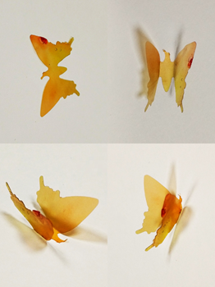
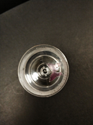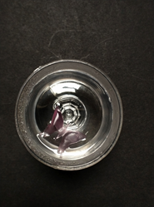
4D Latte Art / 4D 拉花PPT (V20191101)
Youtube: https://youtu.be/Db20L4avjyM
优酷: https://v.youku.com/v_show/id_XNDQyMDk5NDgzMg==.html?spm=a2h3j.8428770.3416059.1

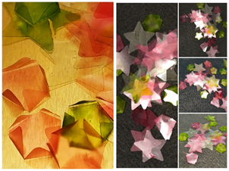 |  |  | 4D latte art/拉花：Flowers open(水上花开)  Youtube: https://youtu.be/tzUjErYE9ds  优酷: https://v.youku.com/v_show/id_XNDQzMjg1NzI0NA==.html?spm=a2hzp.8244740.0.0
茶杯里的谋杀案/Murder in mug  Youtube: https://youtu.be/MIlWKyGebu8  优酷: https://v.youku.com/v_show/id_XNDQ0ODk4NjE4NA==.html?spm=a2hzp.8244740.0.0 |  |  | 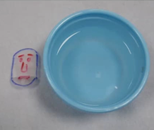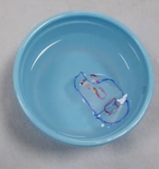
各种展开概念测试 （Testing of various unfolding concepts）
Youtube  https://www.youtube.com/watch?v=C0cwBxi58SM |  |  | 优酷  https://v.youku.com/v_show/id_XNDQ5ODQxODg4OA==.html?spm=a2hzp.8244740.0.0
音乐简版（short version with music）
https://youtu.be/NKxXjfHKYWQ |  |  | https://v.youku.com/v_show/id_XNDQ5ODYyMDU4MA==.html
食品膜测试 （Testing with real food “paper”） |  |  |  | 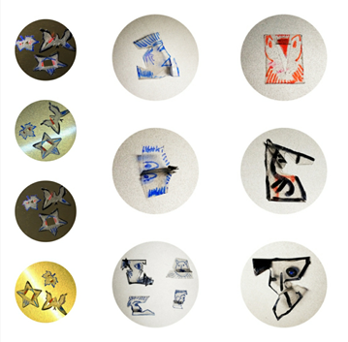
Youtube: https://youtu.be/7sBqxeyqoc8
优酷: https://v.youku.com/v_show/id_XNDUwNjg3NTQzMg==.html?spm=a2hzp.8244740.0.0
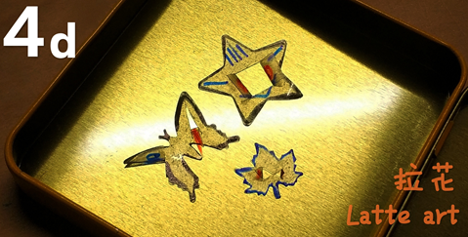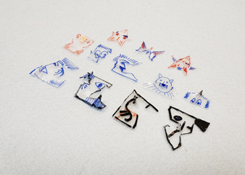
4D 拉花：从概念到真正的食品
4D latte art: from concept to real food
Youtube: https://youtu.be/D4cvsesqrVs |  | 优酷:
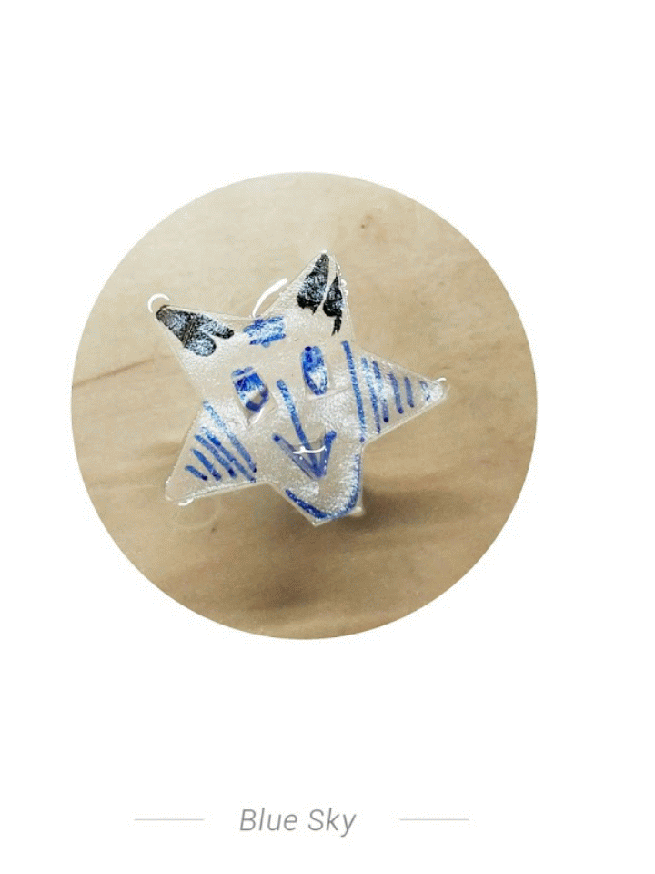
Homepage of 4D Latte Art / 4D拉花 ©SMT

